* Our Election Management system menu

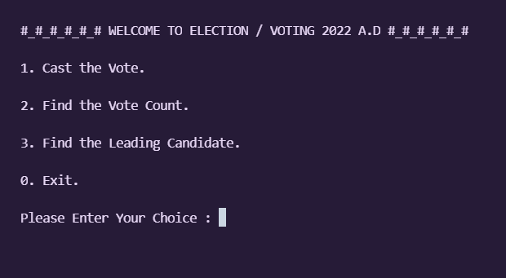

* Choice 1, “Cast the Vote.”

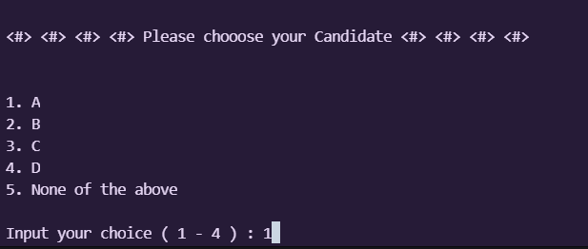

* Choice 2, “Find the Vote Count.”

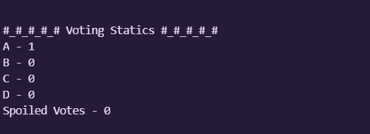

* Choice 3, “Find the Leading Candidate.”

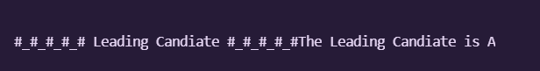

* Choice 0, “Exit.”. This choice pretty much returns an error as Invalid Choice and exits.

